Slide 1

To implement Naive Bayes for this binary classification we’ve chosen Gaussian Naive Bayes.

Why Naive Bayes:

Simple yet powerful

Works well for a wide range of real-world classification problems

Why Gaussian Naive Bayes:

Feature values in our dataset are continuous

How it differs from basic Naive Bayes:

Gaussian Naive Bayes assumes that each class follows a Gaussian distribution

Slide 2

How it works:

For simplicity assume we have only 2 features

1. Calculate the priors

2. Calculate the mean and variance of each feature in each class

3. To give a diagnosis for a new sample calculate posteriors of each class (use Gaussian formula to calculate the likelihoods)

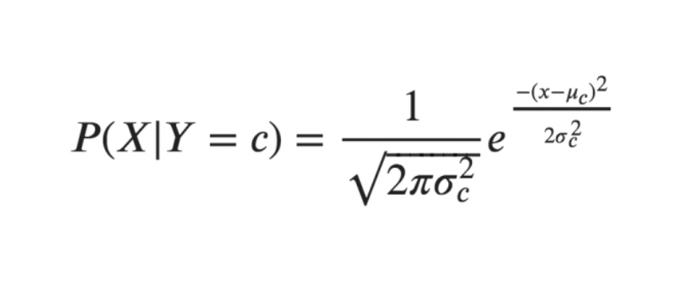

Slide 3

Let’s predict a new sample

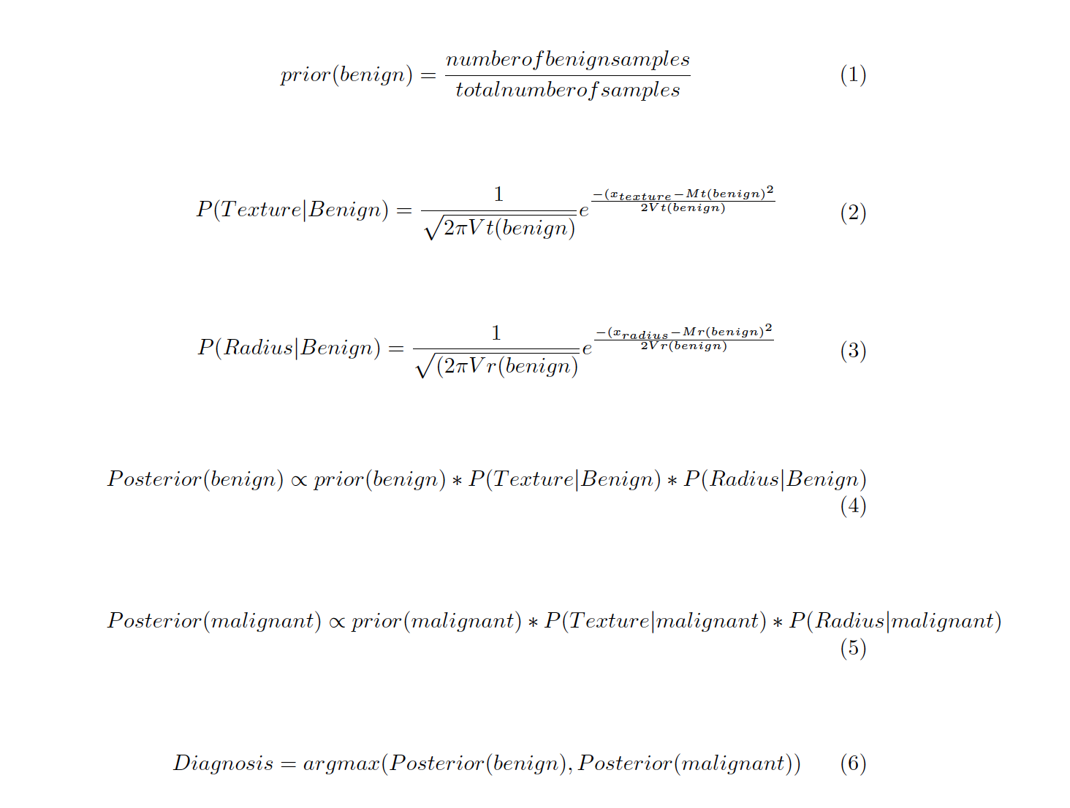

|  | Mean(texture) | Variance(texture) | Mean(radius) | Variance(radius) |
| --- | --- | --- | --- | --- |
| Benign | Mt(benign) | Vt(benign) | Mr(benign) | Vr(benign) |
| Malignant | Mt(malignant) | Vt(malignant) | Mr(malignant) | Vr(malignant) |